Lab 6: DHCP Configuration of VLANs and Inter–VLAN Routing Using Router–on–a–Stick

Theory
1. VLAN (Virtual LAN)
A VLAN (Virtual Local Area Network) is a logical division of a physical network into separate networks. It allows devices connected to the same physical switch to be grouped into different networks based on their department, function, or purpose. Each VLAN acts like a separate broadcast domain.
For example, a network can have separate VLANs for the Accounts, IT, and Management departments. Devices in one VLAN normally cannot communicate directly with devices in another VLAN unless routing is provided. VLANs help organize the network and reduce unnecessary broadcast traffic.
2. Access Port and Trunk Port
An Access Port is a switch port that belongs to a single VLAN. It is normally used to connect end devices such as computers, printers, and other network devices. The connected device does not need to know that VLANs are being used.
A Trunk Port is a switch port that can carry traffic belonging to multiple VLANs. It is mainly used to connect network devices such as switches and routers. VLAN information is added to the traffic so that the receiving device can identify which VLAN the traffic belongs to.
Access Port | Trunk Port
Carries traffic for one VLAN | Carries traffic for multiple VLANs
Usually connects end devices | Usually connects switches or routers
VLAN information is generally not carried to the end device | VLAN information is maintained between network devices
3. Inter-VLAN Routing – Definition and Why It Is Needed
Inter-VLAN Routing is the process of allowing devices in different VLANs to communicate with each other. Since each VLAN is a separate network, devices in different VLANs cannot communicate directly without a Layer 3 routing function.
For example, if a computer in the IT VLAN needs to communicate with a computer in the Accounts VLAN, a router or Layer 3 switch is required to forward the traffic between the two VLANs. Inter-VLAN routing is therefore necessary when communication between different departments or network segments is required.
4. Router-on-a-Stick – Definition and How It Works
Router-on-a-Stick is a method of performing Inter-VLAN Routing using a single physical interface of a router. The router interface is connected to a switch through a trunk link.
The router uses separate logical interfaces, called sub-interfaces, for different VLANs. Each sub-interface is associated with a particular VLAN and has an IP address that acts as the gateway for devices in that VLAN.
When a device sends data to another VLAN, the traffic first reaches the router through the trunk link. The router determines the destination VLAN and forwards the traffic back through the same physical connection. This allows multiple VLANs to communicate while using only one physical router interface.
In this lab, Router-on-a-Stick is also used along with DHCP to provide IP addresses to devices in the different VLANs.
5. Advantages of VLAN
- Improved network organization: Devices can be grouped according to departments, functions, or requirements.
- Reduced broadcast traffic: VLANs divide a network into separate broadcast domains, reducing unnecessary traffic.
- Better security: Devices in different VLANs are separated, making it easier to control communication between groups.
- Efficient use of resources: Multiple logical networks can be created using the same physical switch infrastructure.
- Easy management: Changes in the logical network structure can be made without physically moving network devices.
- Better network performance: By limiting broadcast traffic to individual VLANs, overall network performance can be improved.

6. Disadvantages of VLAN
- More complex configuration: VLANs require additional configuration compared to a basic network.
- Requires routing for communication: Devices in different VLANs need a router or Layer 3 switch to communicate.
- Troubleshooting can be difficult: Problems involving VLANs, trunks, or routing can make network troubleshooting more complicated.
- Configuration errors can affect communication: Incorrect VLAN or trunk settings may prevent devices from communicating properly.
- Additional planning is required: Proper VLAN design and IP addressing are needed as the network grows.

Components Required
- Cisco Packet Tracer
- 1 Router (2901)
- 3 Switches (2960)
- PCs/Laptops
- Copper Straight-Through Cables
- Copper Cross-Over Cables

Procedure:
- Network Topology
Steps:
- Open Cisco Packet Tracer.
- Place a router, three switches, and end devices in the workspace.
- Connect:
  - PCs/Laptops to their respective switches.
  - Switches to routers using Copper Straight-Through cables.
  - Connect both routers together.
- Document the necessary IP addresses.
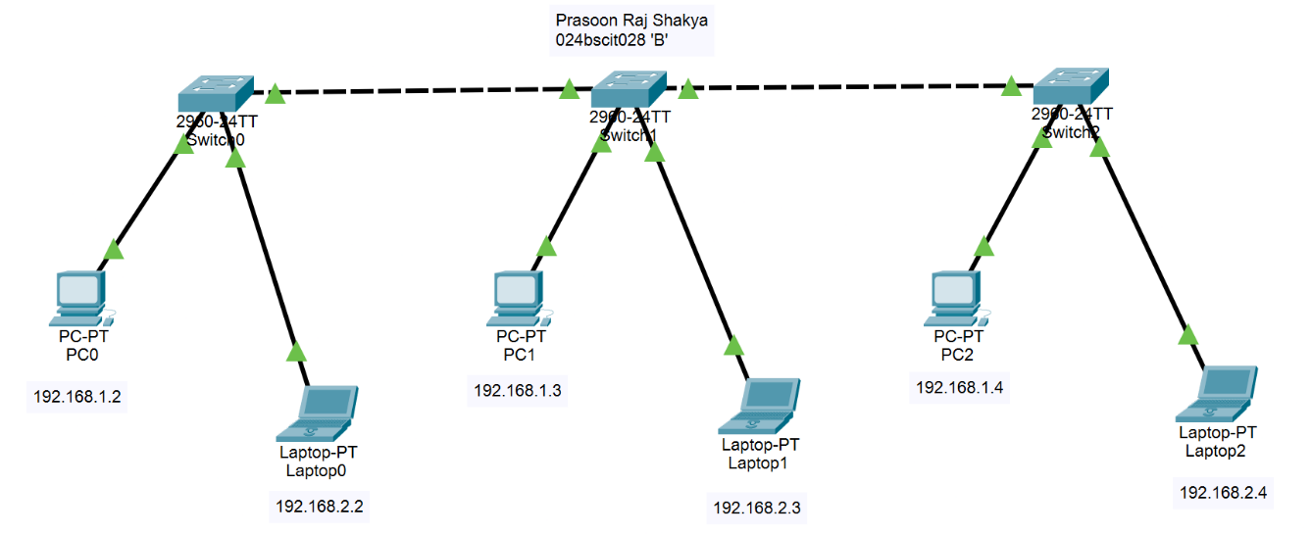
- Static IP Address Assignment
Steps:
- Assign IP addresses to the end devices according to their respective VLANs.
- The devices in VLAN 10 belong to the 192.168.1.0/24 network, while devices in VLAN 20 belong to the 192.168.2.0/24 network.
- Before Inter-VLAN Routing is configured, communication between different VLANs is unsuccessful, as shown in the output.
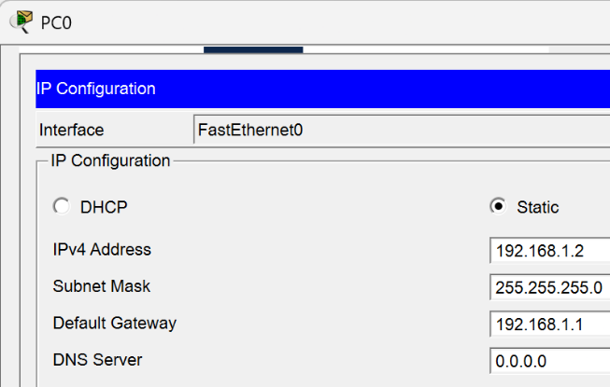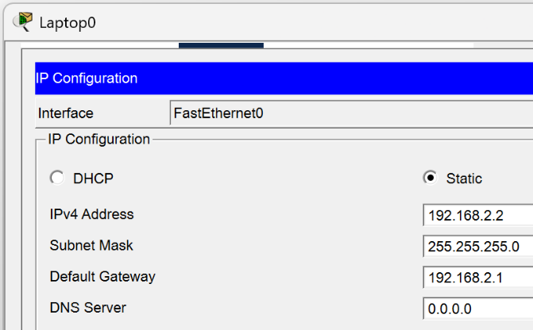
IP Addressing Scheme
Device & Interface | Switch & Interface | IP Address | Default Gateway | VLAN
PC0 – Fa0/1 | Prasoon_S0 – G0/1 | 192.168.1.2 | 192.168.1.1 | VLAN 10
PC1 – Fa0/1 | Prasoon_S1 – G0/1 | 192.168.1.3 | 192.168.1.1 | VLAN 10
PC2 – Fa0/1 | Prasoon_S2 – G0/2 | 192.168.1.4 | 192.168.1.1 | VLAN 10
Laptop0 – Fa0/2 | Prasoon_S0 – G0/1 | 192.168.2.2 | 192.168.2.1 | VLAN 20
Laptop1 – Fa0/2 | Prasoon_S1 – G0/2 | 192.168.2.3 | 192.168.2.1 | VLAN 20
Laptop2 – Fa0/2 | Prasoon_S2 – G0/2 | 192.168.2.4 | 192.168.2.1 | VLAN 20
Network and VLAN Scheme
Network | Network Address | Subnet Mask | VLAN | Gateway | Port
Admin Network | 192.168.1.0/24 | 255.255.255.0 | VLAN 10 | 192.168.1.1 | Fa0/1
IT Network | 192.168.2.0/24 | 255.255.255.0 | VLAN 20 | 192.168.2.1 | Fa0/2
- Pinging from VLAN 10 to VLAN 20
PC0 to Laptop0
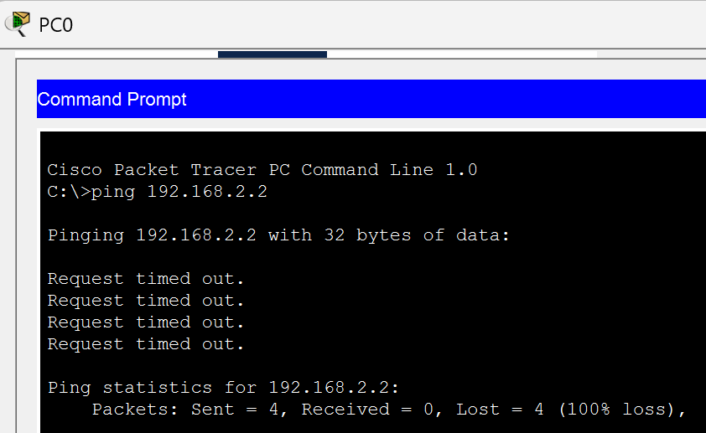
Result: Unsuccessful
- VLAN Creation
Steps:
- Open the CLI of the first switch in Cisco Packet Tracer.
- Enter the switch configuration mode.
- Create VLAN 10 and assign it a suitable name, such as Admin.
- Create VLAN 20 and assign it a suitable name, such as IT.
- Assign the ports connected to the PCs to VLAN 10.
- Assign the ports connected to the laptops to VLAN 20.
- Repeat the VLAN creation and port assignment process on the other switches.
- Verify that the required ports are assigned to their respective VLANs.
- Check the VLAN status on each switch to confirm that:
  - VLAN 10 contains the PC ports.
  - VLAN 20 contains the laptop ports.
- At this stage, devices belonging to the same VLAN should be able to communicate, while communication between VLAN 10 and VLAN 20 will still be unsuccessful until Inter-VLAN Routing is configured.
CLI for VLAN creation:
Switch>en
Switch#conf t
Enter configuration commands, one per line. End with CNTL/Z.
Switch(config)#hostname Prasoon_S0
Prasoon_S0(config)#vlan 10
Prasoon_S0(config-vlan)#name Admin
Prasoon_S0(config-vlan)#exit
Prasoon_S0(config)#vlan 20
Prasoon_S0(config-vlan)#name IT
Prasoon_S0(config-vlan)#exit
Prasoon_S0(config)#exit
Prasoon_S0#
%SYS-5-CONFIG_I: Configured from console by console

CLI for verification
Prasoon_S0#show vlan brief
VLAN Name Status Ports
---- -------------------------------- --------- -------------------------------
1 default active Fa0/1, Fa0/2, Fa0/3, Fa0/4
Fa0/5, Fa0/6, Fa0/7, Fa0/8
Fa0/9, Fa0/10, Fa0/11, Fa0/12
Fa0/13, Fa0/14, Fa0/15, Fa0/16
Fa0/17, Fa0/18, Fa0/19, Fa0/20
Fa0/21, Fa0/22, Fa0/23, Fa0/24
Gig0/1, Gig0/2
10 Admin active
20 IT active
1002 fddi-default active
1003 token-ring-default active
1004 fddinet-default active
1005 trnet-default active
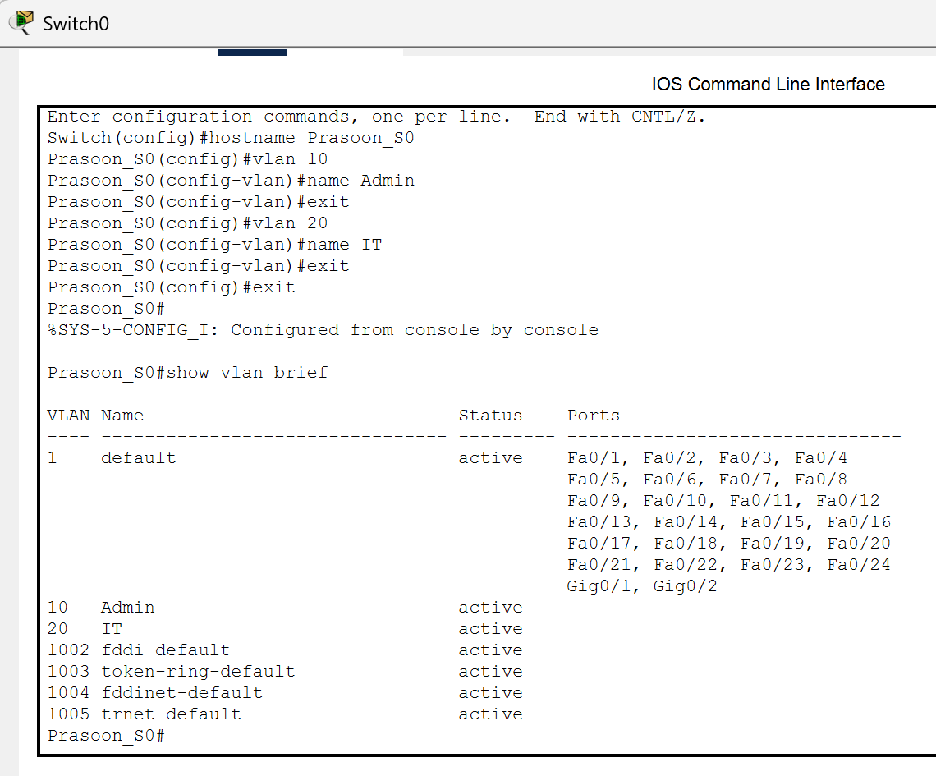
- Port Assignment
Steps:
- Configure VLAN 10 (Admin) and VLAN 20 (IT) on all three switches.
- Assign Fa0/1 as an access port for VLAN 10 and Fa0/2 as an access port for VLAN 20 on each switch.
- Configure the required GigabitEthernet ports as trunk ports to allow traffic from multiple VLANs.
- Verify the VLAN configuration using the VLAN status table and confirm that the correct ports are assigned to VLAN 10 and VLAN 20.
CLI:
Prasoon_S0#conf t
Enter configuration commands, one per line. End with CNTL/Z.
Prasoon_S0(config)#interface fastEthernet 0/1
Prasoon_S0(config-if)#switchport mode access
Prasoon_S0(config-if)#switchport access vlan 10
Prasoon_S0(config-if)#exit
Prasoon_S0(config)#interface f0/2
Prasoon_S0(config-if)#switchport mode access
Prasoon_S0(config-if)#switchport access vlan 20
Prasoon_S0(config-if)#exit
Prasoon_S0(config)#interface gigabitethernet 0/1
Prasoon_S0(config-if)#switchport mode t
Prasoon_S0(config-if)#switchport mode trunk
Prasoon_S0(config-if)#
%LINEPROTO-5-UPDOWN: Line protocol on Interface GigabitEthernet0/1, changed state to down
%LINEPROTO-5-UPDOWN: Line protocol on Interface GigabitEthernet0/1, changed state to up
Prasoon_S0(config-if)#exit
Prasoon_S0(config)#interface giga
Prasoon_S0(config)#interface gig
Prasoon_S0(config)#interface gigabitEthernet 0/2
Prasoon_S0(config-if)#switchport mode t
Prasoon_S0(config-if)#switchport mode trunk
Prasoon_S0(config-if)#exit
Prasoon_S0(config)#exit
Prasoon_S0#
%SYS-5-CONFIG_I: Configured from console by console
- Repeat the same configuration for Prasoon_S0, Prasoon_S1, and Prasoon_S2.
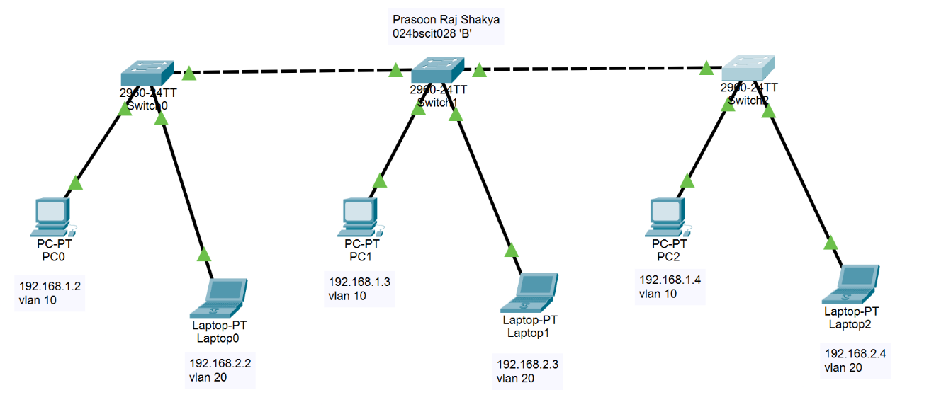
Checking if endpoints are communicating or not
- Pinging from 192.168.1.2
PC0 to Laptop0
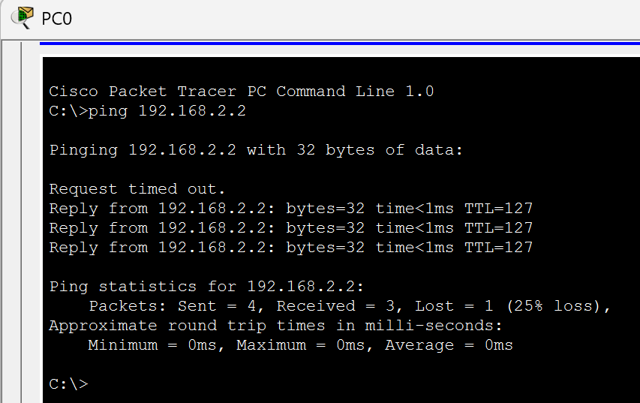
Result: Successful

6. Configuration of Inter-VLAN Routing Using Router-on-a-Stick
Steps:
- Enable the router's GigabitEthernet 0/0 interface and create subinterfaces G0/0.10 and G0/0.20 for VLAN 10 and VLAN 20.
- Assign 192.168.1.1/24 to VLAN 10 and 192.168.2.1/24 to VLAN 20 as their respective gateway addresses.
- Configure 802.1Q encapsulation on the subinterfaces to identify VLAN 10 and VLAN 20 traffic.
- Save the router configuration and verify the connection between the VLANs by sending ping requests between devices in different VLANs.
CLI:
Router>en
Router#conf t
Enter configuration commands, one per line. End with CNTL/Z.
Router(config)#int
Router(config)#interface gigabit
Router(config)#interface gigabitEthernet 0/0
Router(config-if)#no shutdown
Router(config-if)#
%LINK-5-CHANGED: Interface GigabitEthernet0/0, changed state to up
%LINEPROTO-5-UPDOWN: Line protocol on Interface GigabitEthernet0/0, changed state to up
Router(config-if)#interface gigabitEthernet 0/0.10
Router(config-subif)#
%LINK-3-UPDOWN: Interface GigabitEthernet0/0.10, changed state to down
%LINEPROTO-5-UPDOWN: Line protocol on Interface GigabitEthernet0/0.10, changed state to up
Router(config-subif)#encapsulation dot1Q 10
Router(config-subif)#ip address 192.168.1.1 255.255.255.0
Router(config-subif)#exit
Router(config)#interface gigabit
Router(config)#interface gigabitEthernet 0/0.20
Router(config-subif)#
%LINK-3-UPDOWN: Interface GigabitEthernet0/0.20, changed state to down
%LINEPROTO-5-UPDOWN: Line protocol on Interface GigabitEthernet0/0.20, changed state to up
Router(config-subif)#encapsulation dot1Q 20
Router(config-subif)#ip address 192.168.2.1
% Incomplete command.
Router(config-subif)#ip address 192.168.2.1 255.255.255.0
Router(config-subif)#exit
Router(config)#exit
Router#
%SYS-5-CONFIG_I: Configured from console by console
Router#wr
Building configuration...
[OK]
IP Addressing Scheme
Device | Interface | IP Address | Connected To | Network
Router | G0/0.10 | 192.168.1.1 | VLAN 10 | 192.168.1.0/24
Router | G0/0.20 | 192.168.2.1 | VLAN 20 | 192.168.2.0/24

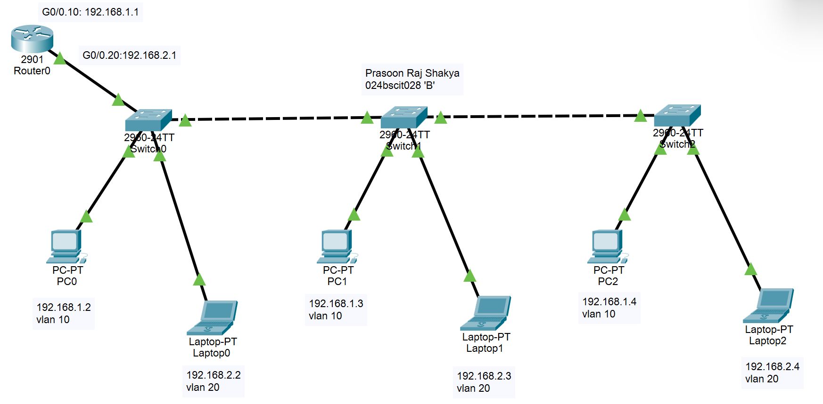

PC0 to Laptop1
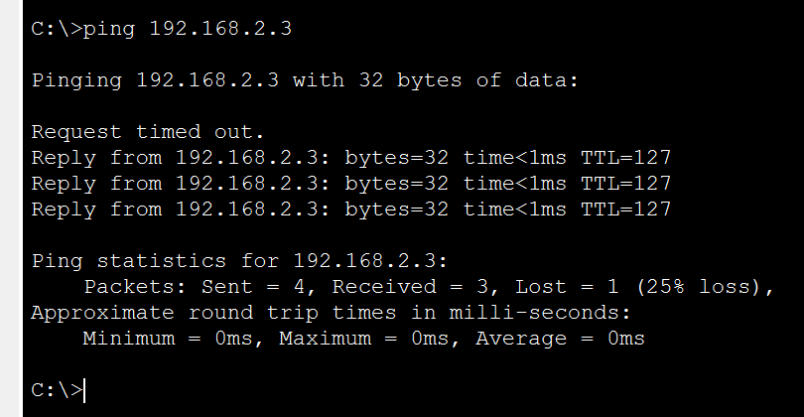
Result: Successful

PC0 to Laptop2
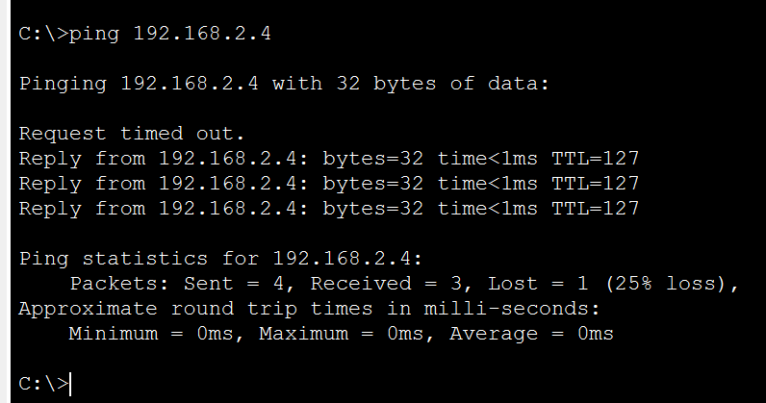
Result: Successful

Observation
Before any VLAN configuration, a ping from PC0 (192.168.1.2) to Laptop0 (192.168.2.2) was unsuccessful. After creating VLAN 10 (Admin) and VLAN 20 (IT) on all three switches and assigning the access and trunk ports, devices within the same VLAN could communicate, but inter-VLAN communication still failed. After configuring Router-on-a-Stick with subinterfaces G0/0.10 and G0/0.20 using 802.1Q encapsulation, all pings between PC0 and Laptop0, Laptop1, and Laptop2 became successful.

Conclusion
VLANs divide a physical network into separate broadcast domains, improving organization, security, and performance. However, devices in different VLANs cannot communicate without Layer 3 routing. The Router-on-a-Stick method proved an efficient solution, enabling inter-VLAN communication using a single physical router interface with logical subinterfaces. Overall, VLANs combined with proper routing create a scalable and well-organized network, though they require careful configuration and troubleshooting.

